FIXED EFFECTS MODELS (PANEL REGRESSION)

A longitudinal panel analysis using annual country-level data for 47 countries observed over an unbalanced period spanning up to 18 years. The analysis combined demographic, macroeconomic, health financing, health workforce, and health outcome indicators to examine the relationship between human resources for health (HRH) and key health system outcomes.The data was sourced from credible international sources including WHO and world bank.
Two primary outcomes were examined the life expectancy at birth (LE) measured in years and used as a summary indicator of population health and Universal Health Coverage Service Coverage Index (UHC_SCI) . The main explanatory variable of interest was measures of health workforce availability, expressed as densities per population:
Workforce density was constructed as the number of physicians, pharmacists, dentists, and nursing/midwifery personnel per 10,000 population. To account for broader demographic, health system and economic context, the models also included .The ratio of Government health expenditure per capita (GGHED per capita) to Gross domestic product per capita (GDP per capita) and population density.
The main objective was to estimate the association between health workforce density and UHC service coverage and life expectancy; assess nonlinear and threshold effects in the workforce–outcome relationship; and identify workforce density levels associated with diminishing marginal returns.
First, we estimate the longitudinal association between health workforce density and health system performance, measured by life expectancy at birth (LE) and the Universal Health Coverage Service Coverage Index (UHC_SCI), using country-level panel data.
We then test for the presence of a structural breakpoint (kink) in the workforce–outcome relationship, allowing for differential marginal effects below and above an empirically determined workforce density threshold.
Finally, we identify the workforce density level at which marginal returns to workforce expansion decline, indicating a transition from a workforce-constrained regime to a moderate-return regime.

Statistical Approach
Panel regression models were estimated using both fixed-effects and random-effects specifications. Hausman tests were used to guide model selection.We then added a kink (piecewise linear) model that allows the marginal effect of an explanatory variable to change at an unknown threshold. The baseline Panel model is given by:
$$Y_{it}=∝_{i}+τ_{t}+βW_{it}+X_{it}+ϵ_{it}$$
Where
$Y_{it}$= outcome variable (e.g., LE or UHC_SCI)
$W_{it}$ = workforce density
$X_{it}$= vector of control variables
$∝_{i}$= country-specific fixed effect
​ $τ_{i}$= time (year) fixed effect
$ϵ_{it}$- Error term
To allow for a structural change in marginal effects at an unknown threshold $k$, we define
$${(W_{it}-k)}_{+}=max⁡(0,W_{it }-k)$$
The kink model will be
$$Y_{it}=∝_{i}+τ_{t}+β_{1}W_{it}+β{(W}_{it}-k)+X_{it}+ϵ_{it}$$
The threshold is estimated as
$$\hat{k}=arg \min_{k}{\sum_{i,t }{{{\hat{ϵ}}_{it}^{2}}_{}}}$$
Results
Universal Health Coverage
We compared the fitted fixed effects and random effects model. From the Hausman test ($χ^{2}=11.5, df=25, p-value<0.001)$,we rejected the null hypothesis and conclude that the random effects model was inconsistent because the individual-specific errors are correlated with the regressors. We therefore report the fixed effects model.
In fixed-effects panel models adjusting for year effects, population density and government health expenditure ,workforce density was positively associated with UHC service coverage. A one-unit increase in workforce density (per 10,000 population) was associated with a 0.11-point increase in UHC-SCI (β = 0.110, p = 0.004). The coefficients for factor(Year) show a clear upward trend. Starting around 2006, the time effects become highly significant and increase in magnitude (from 10.8 in 2006 to 22.9 in 2023). This indicates a strong global or systemic improvement in UHC scores over time that isn't explained by your three main independent variables.
From the piece wise regression, the estimated kink term capturing a change in marginal returns above the candidate threshold was not statistically significant (β = 0.043, p = 0.72), indicating no evidence of a discrete breakpoint in the workforce–UHC relationship.
A grid-search procedure was used to identify the workforce density threshold minimizing the residual sum of squares in fixed-effects models. The optimal breakpoint was identified at approximately 9 health workers per 10,000 population for UHC( figure 1). This threshold represents the transition from ‘extreme health workforce crisis’ to ‘basic functional capacity’. It is the point where basic primary care geared towards UHC begins to stabilize. However, the slope-change parameter was not statistically significant, suggesting that while marginal returns may diminish beyond this level, there is no evidence of a discrete structural break.
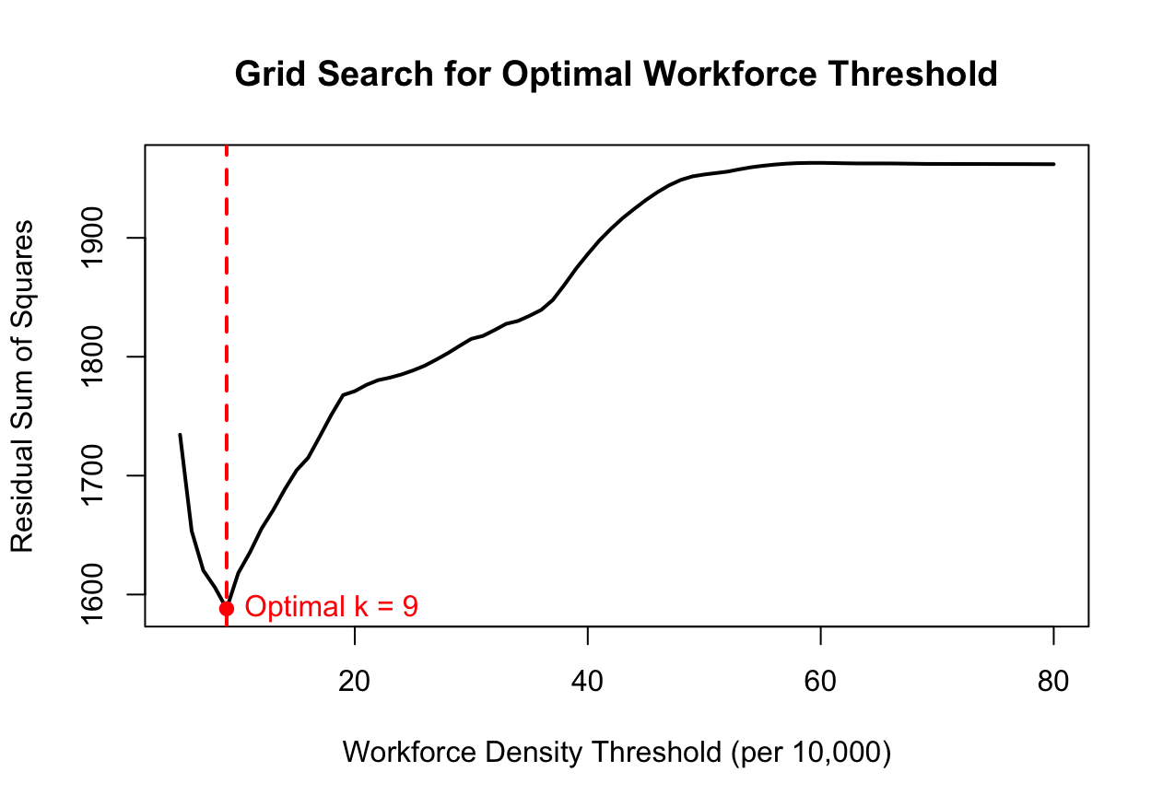
Figure 1: Workforce density threshold for UHC
Life expectancy outcome
There was no statistically significant difference between the fixed effects and random effects coefficients (Hausman test ($χ^{2}=0.0669, df=23, p-value=0.9999$ )).
In random-effects panel models adjusting for population density, government health expenditure, and year effects, workforce density was not significantly associated with life expectancy (β = 0.016, p = 0.41). The estimated slope change above the optimal breakpoint (38 workers per 10,000 population) was negative but statistically insignificant (β = –0.079, p = 0.16), providing no evidence of a structural threshold in the workforce–longevity relationship. The life expectancy at birth (LE) threshold of 38.0 is closer to the broader WHO global benchmarks and represents the population health impact.
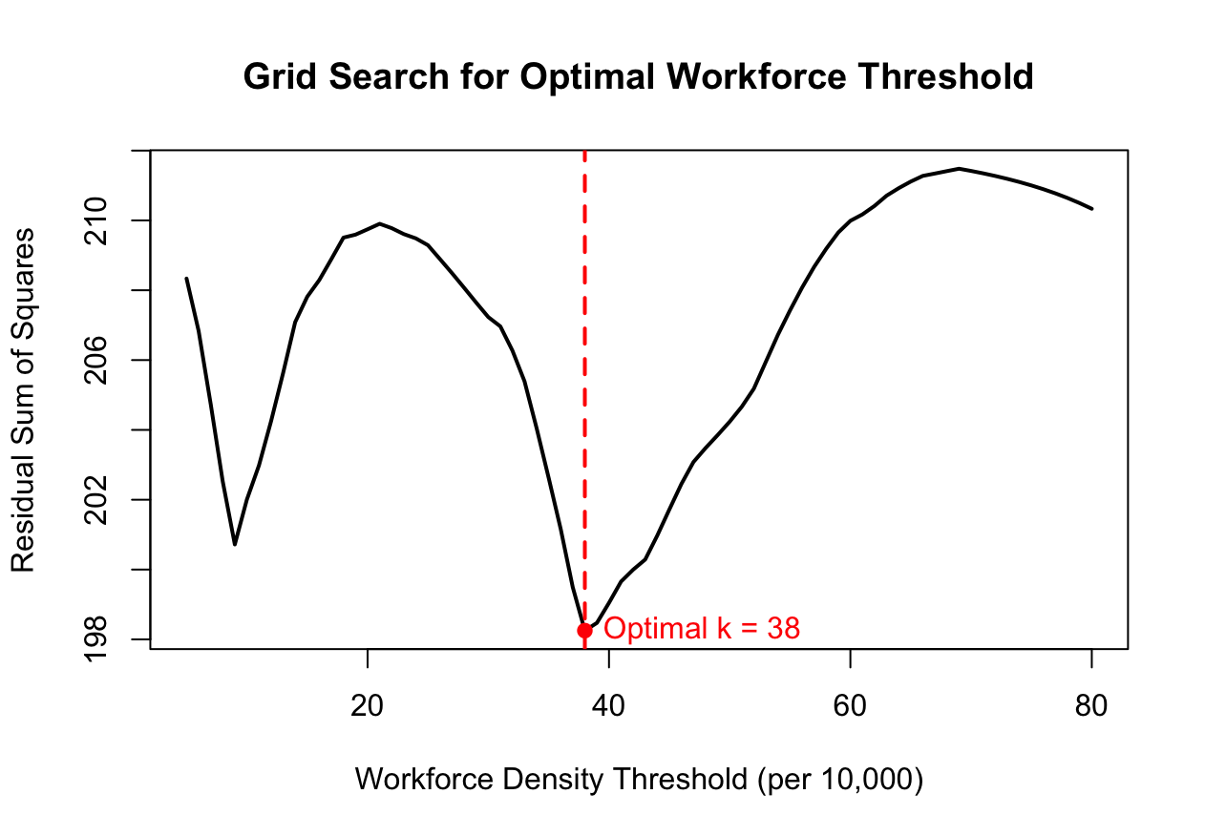
Figure 2: Workforce density threshold for Life Expectancy

Comparison
Health workforce density is a critical driver for the UHC Service Coverage Index( UHC_SCI) but does not significantly impact life expectancy. Hiring more health workforce directly improves service delivery (vaccinations, prenatal care, hospital access), which raises the UHC score.On the other hand, life expectancy is influenced by broader factors not necessarily the health work force.
While a density of 9 health workers per 10,000 serves as the critical breakpoint for expanding service coverage (UHC), a significantly higher density of 38 per 10,000 is required to achieve structural improvements in life expectancy. This suggests that service coverage is a necessary but insufficient precursor to longevity, requiring nearly a four times increase in workforce density to translate into extended life expectancy.

